**Ride-Sharing or Taxi Dispatch System**



Case Study Report

Group: 4A

Presented By:

|  |  |
| --- | --- |
| Purnima Pattnaik | 2201020960 |



Under the Guidance of:

Mr.Bichitrananda Behera Sir

**Abstract**

In the dynamic landscape of urban transportation, the implementation of an efficient and responsive ride-sharing or taxi dispatch system is pivotal. This project serves as a comprehensive case study showcasing the strategic use of diverse data structures to optimize the management of ride requests, driver allocation, route planning, and real-time updates for users.

The project encompasses key features such as secure user registration, prioritized ride request handling using dynamic data structures, intelligent driver allocation algorithms, and real-time tracking mechanisms. It also addresses route planning and optimization through suitable data structures, dynamic pricing mechanisms, and a feedback system for user ratings.

By employing the appropriate technologies and tools, the project aims to illustrate the significance of data structure selection in enhancing the overall efficiency and user experience of contemporary transportation systems. Through this case study, we intend to provide valuable insights into the intricate design considerations and optimization strategies involved in creating a cutting-edge ride-sharing or taxi dispatch system, emphasizing the critical role of data structures in shaping the future of urban mobility solutions.

**Content**

page no

1. Introduction------------------------------------
2. Model design /Algorithm --------------------
3. Screenshots of Coding------------------------
4. Results------------------------------------------
5. Conclusion-------------------------------------

6 References--------------------------------------

**Introduction**

In the fast-paced and ever-expanding urban environment, the demand for innovative and efficient transportation solutions has led to the evolution of ride-sharing and taxi dispatch systems. These systems serve as the backbone of modern urban mobility, seamlessly connecting users with available transportation resources while optimizing routes and enhancing overall user experience. This project, endeavors to delve into the intricate design and implementation aspects of such systems, emphasizing the pivotal role that carefully selected data structures play in their functionality and performance.

Urban transportation systems face a myriad of challenges, ranging from managing a surge in ride requests to optimizing driver allocation, considering real-time traffic conditions, and ensuring a reliable and dynamic user experience. By focusing on the strategic use of data structures, this project aims to unravel the complexities associated with building a responsive and intelligent ride-sharing platform.

The integration of secure user registration, dynamic ride request management, intelligent driver allocation algorithms, real-time updates, and route optimization are key components that will be explored in this case study. The overarching goal is to showcase how the right selection and implementation of data structures contribute to the efficiency, scalability, and reliability of ride-sharing and taxi dispatch systems.

Model design /Algorithm

**1. Check if a registered driver is available.  
2. Check if taxis are initialized.  
3. Check if a registered taxi is available:  
 - If available, proceed; otherwise, notify the user.  
4. Get user input for current location and destination.  
5. Convert user input to vertex indices.  
6. Call the Bellman-Ford algorithm to find the optimal path and distance.  
7. Update the distance traveled by the booked taxi.  
8. Ask the user if they want to continue with the order.  
9. If the user cancels the order, set the taxi as available again.  
10. Display the result to the user, indicating a successful booking or cancellation.**

**code:**

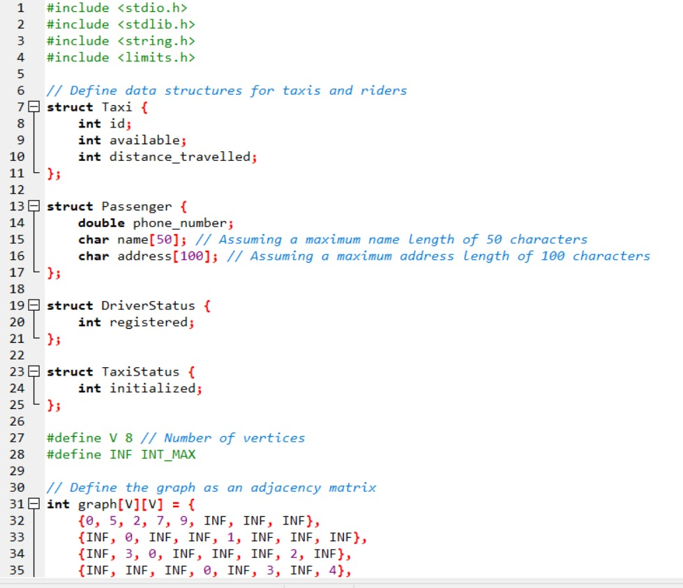

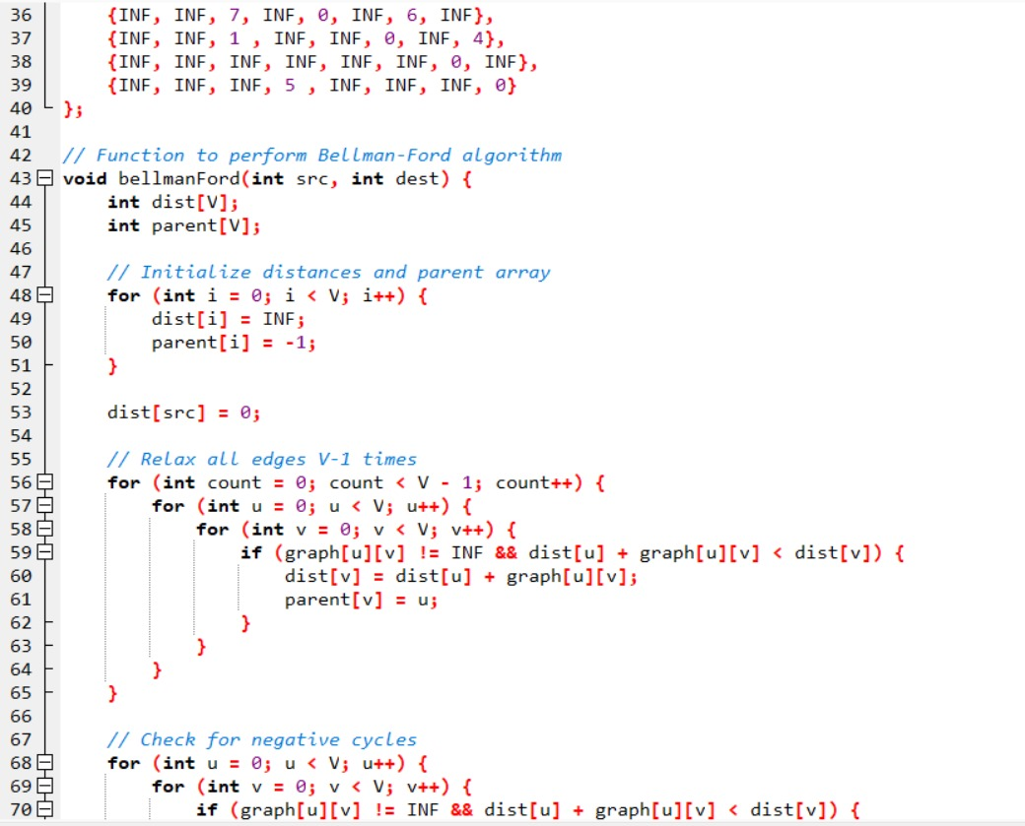

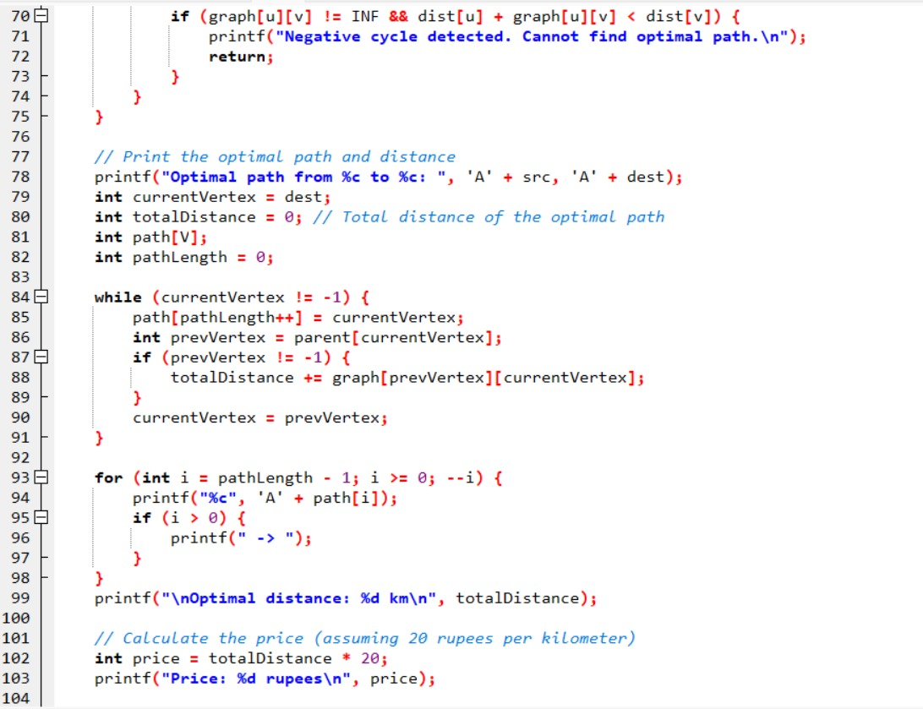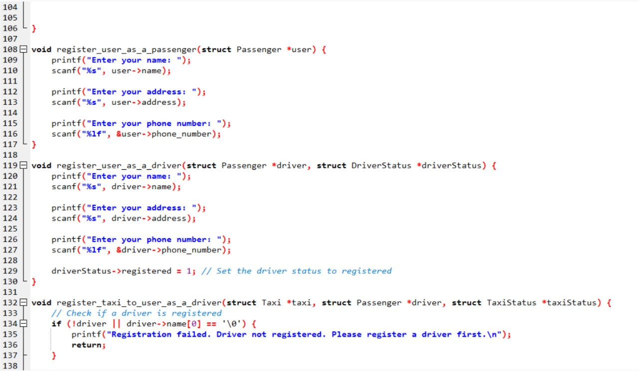

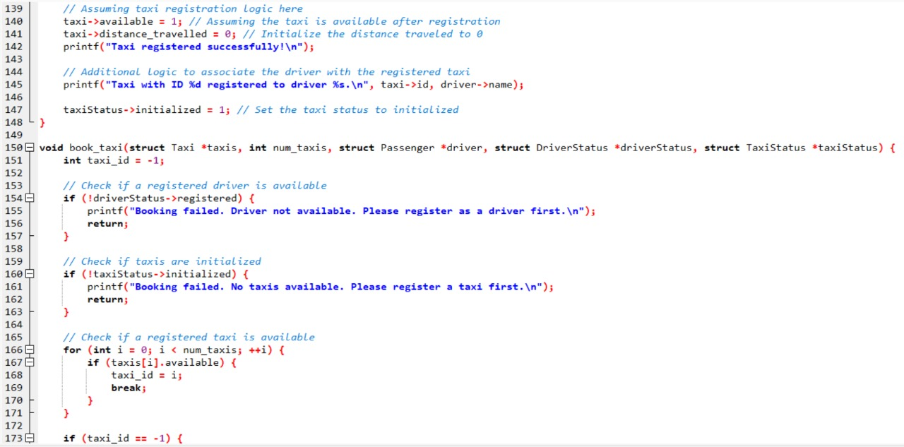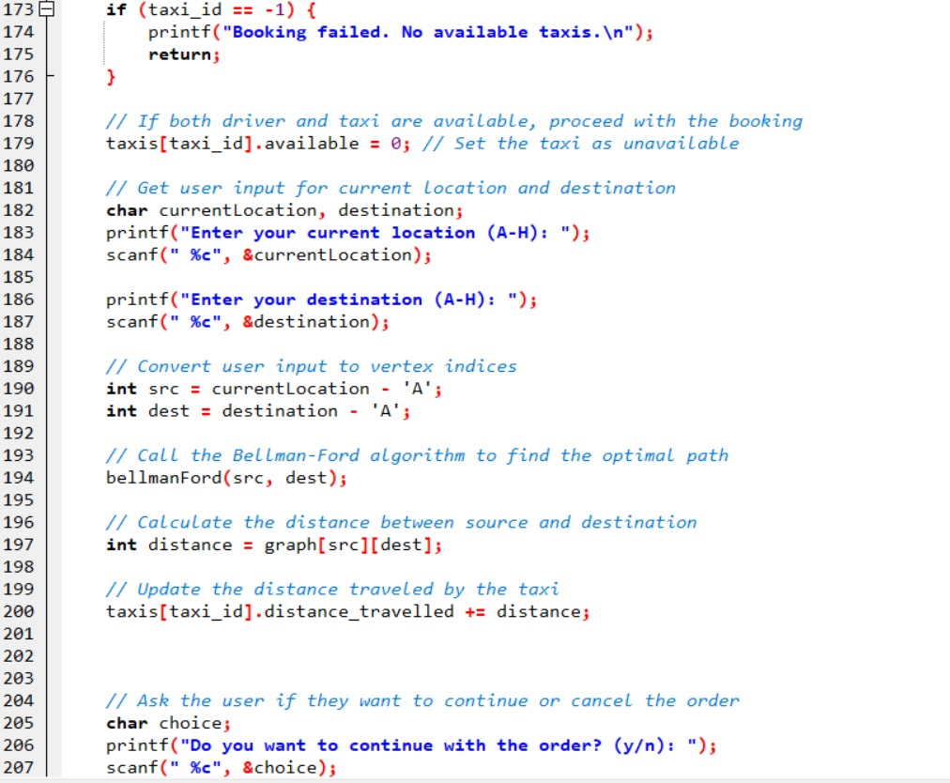

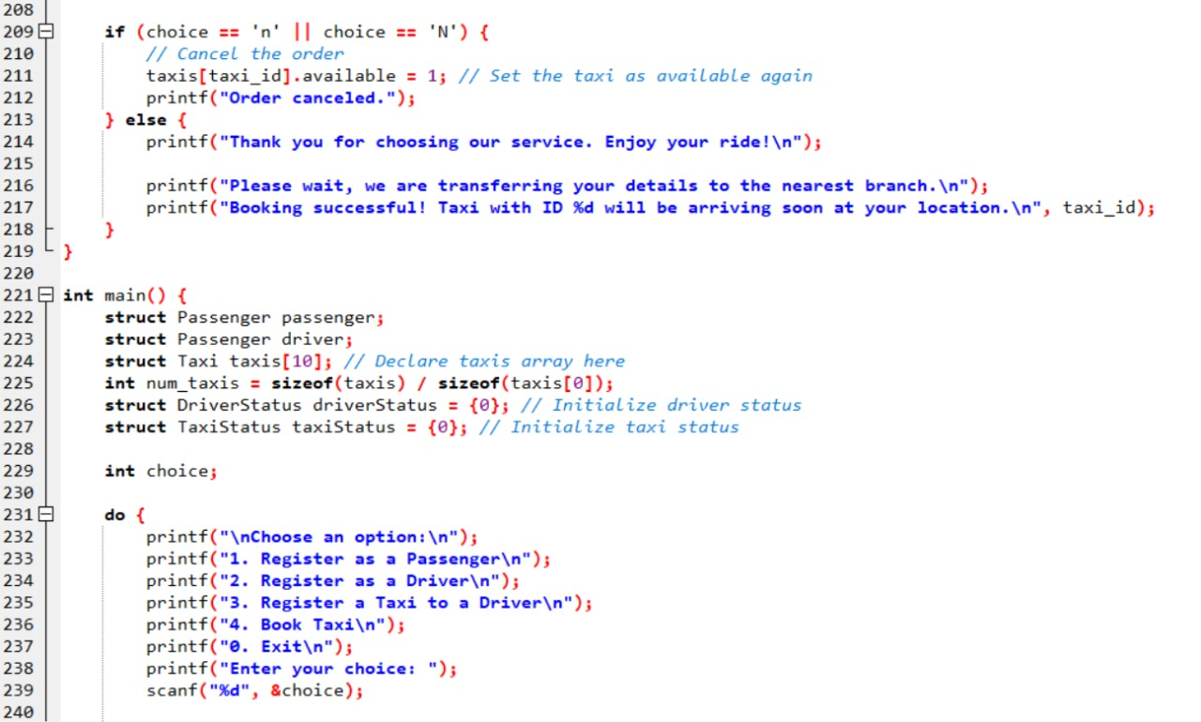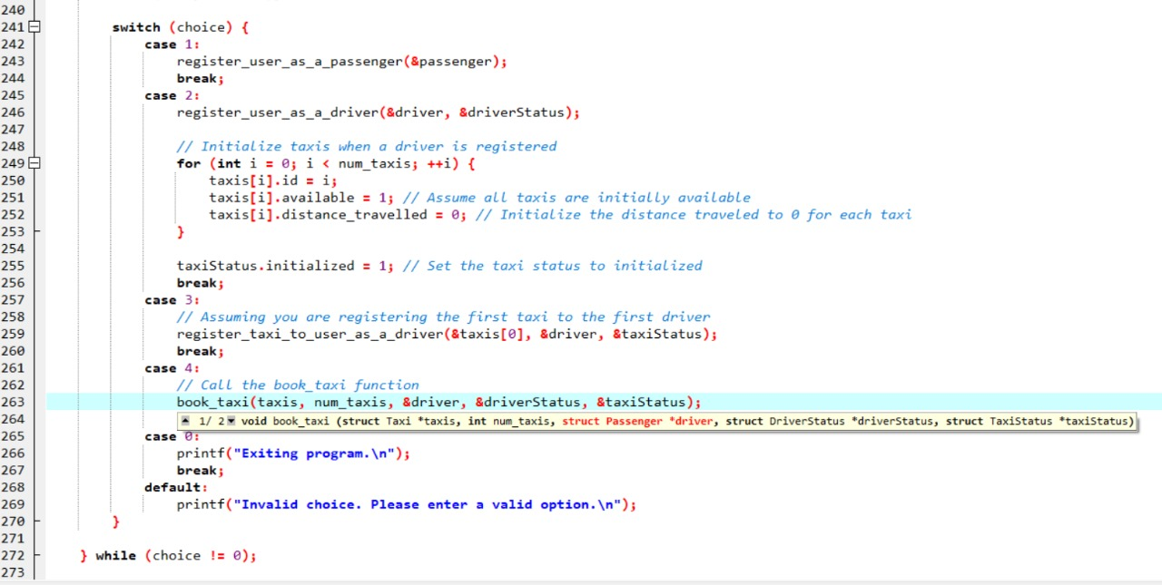

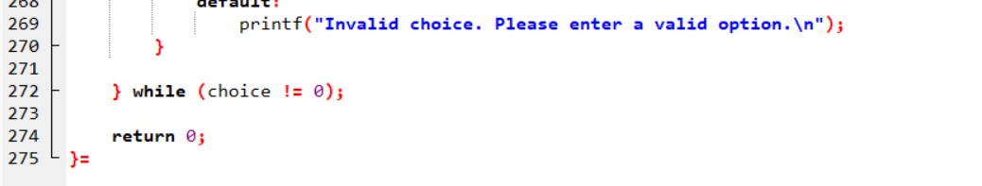

**Result(output):**

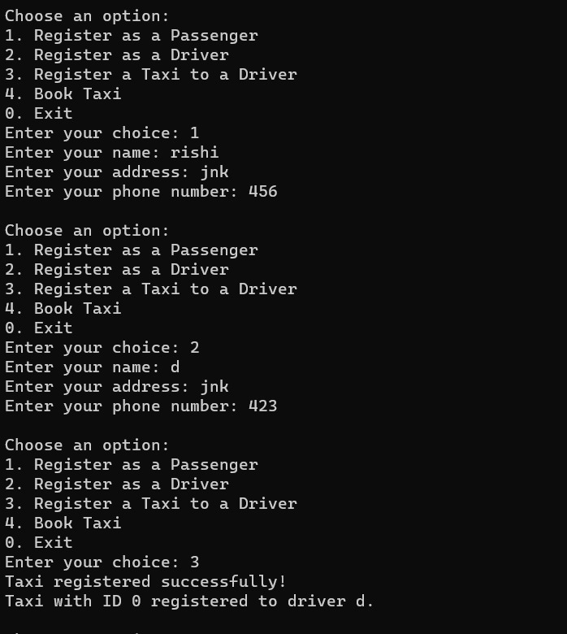

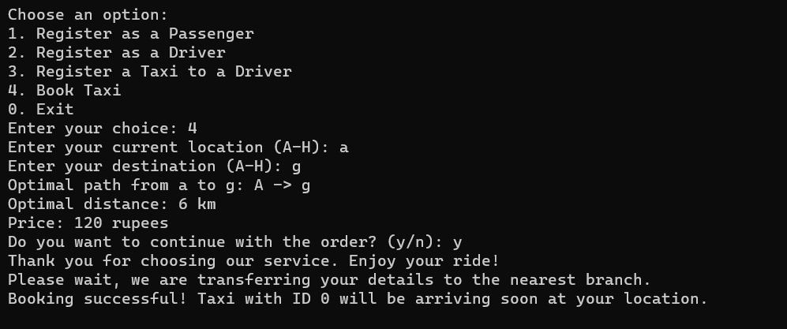

**Conclusion:**

The development and exploration of the Efficient Ride-Sharing and Taxi Dispatch System underscore the critical role of advanced data structures in shaping the future of urban transportation. The project has successfully demonstrated the feasibility and advantages of employing sophisticated algorithms and structures to overcome challenges in ride request management, driver allocation, and real-time updates.

By addressing the complexities of modern urban mobility, this project highlights the significance of data structure selection in achieving optimal performance and responsiveness. The optimized handling of ride requests, intelligent driver allocation, and dynamic route planning, enabled by carefully chosen data structures, contribute to an enhanced user experience and operational efficiency.

As technology continues to advance, the insights gained from this project serve as a foundation for future innovations in transportation technology. The seamless integration of advanced data structures not only addresses current challenges but also anticipates and prepares for the evolving demands of urban mobility.

**Thank you**